A2204-Asia-China-Zhou Dynasty-Chüeh-Bronze-1100-771 BCE

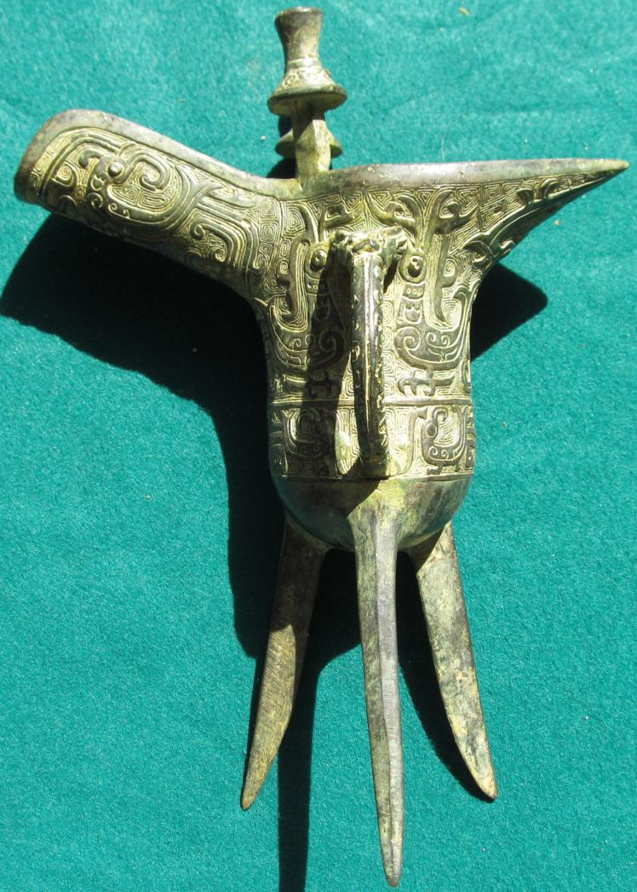

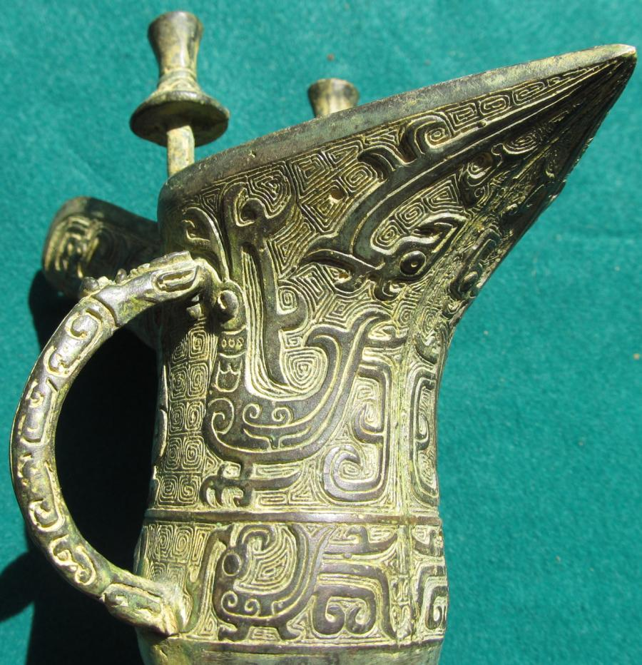 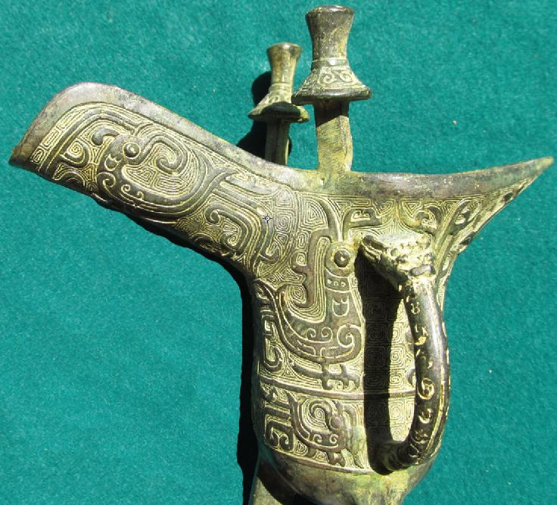 SHAPE \* MERGEFORMAT 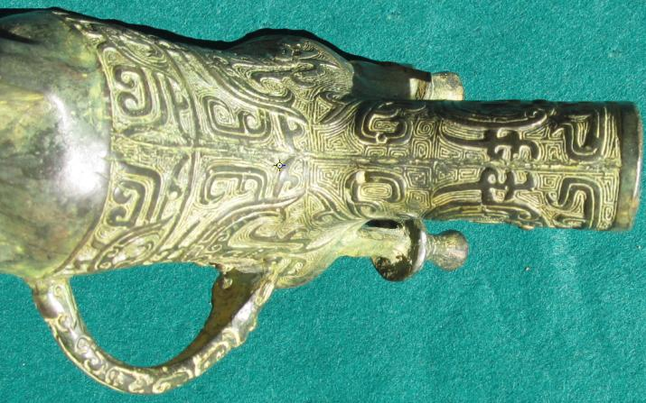 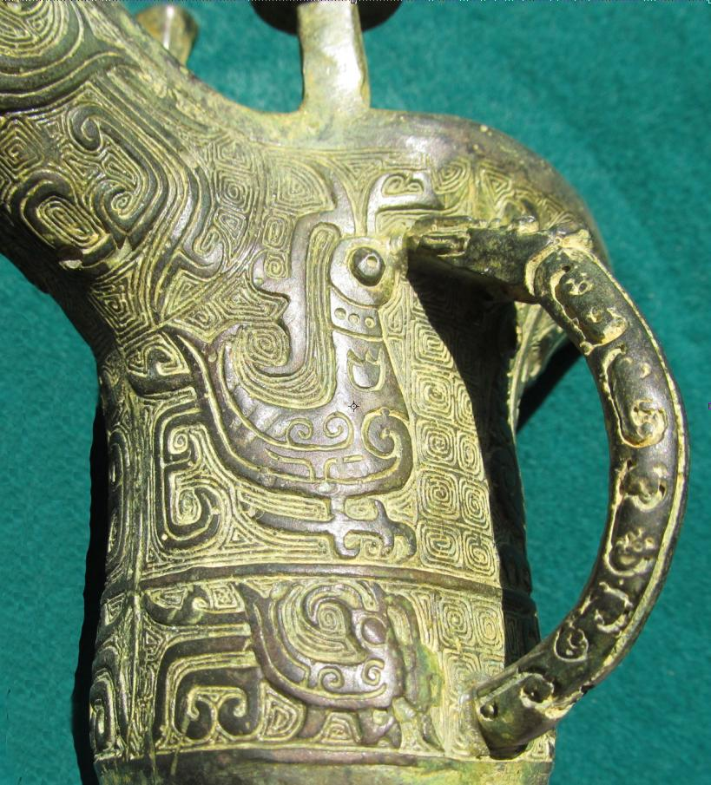 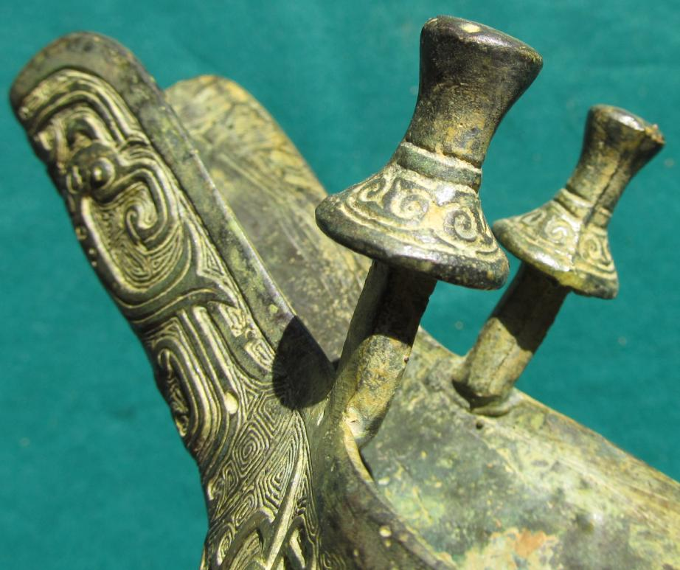

Figs. 1-6. China-Zhou Dynasty-Chüeh-Bronze-1100-771 BCE

Case No.: 5

**Accession No.**

Formal Label:

China-Zhou Dynasty-Chüeh-Bronze-1100-771 BCE

**Display Description:**

Ritual bronzes of the early Western Zhou (Xizhou) were made by the same craftsmen and by their descendants of the late Anyang period. New motifs were developed such as a flamboyant long-tailed bird that may have had totemic meaning for the Zhou rulers akin to the rising phoenix. By the end of the 9th century, moreover, certain Shang shapes such as the jue, gu, and gong were no longer being made, and the taotie and other Shang zoomorphs had been broken up and then dissolved into volutes or undulating meander patterns encircling the entire vessel, scales, and fluting, with little apparent symbolic intent.

From the outset of Zhou rule, vessels increasingly came to serve as vehicles for inscriptions that were cast to record events and report them to ancestral spirits. An outstanding example, excavated near Xi’an in 1976, was dedicated by a Zhou official who apparently had divined the date for the successful assault upon the Shang and later used his reward money to have the bronze vessel cast. By late Zhou times a long inscription might have well over 400 characters.

Vessel shapes, meanwhile, had become aggressive or heavy and sagging, and the quality of the casting was seldom as high as in the late Shang. These changes, completed by the 8th century BCE, mark the middle Zhou phase of bronze design.

The bronzes of the Eastern Zhou (Dongzhou) period, after 771 BCE, show signs of a gradual renaissance in the craft and much regional variation, which appears ever more complex as more Eastern Zhou sites are unearthed. Often adorned with boldly modeled handles in the form of animal heads, 8th- and 7th-century bronzes are crude and vigorous in shape. Typical vessels of this phase have been found in a cemetery of the small feudal state of Guo in Henan province. Vessels from Xinzheng in Henan (8th–6th century BCE) reveal a further change to more elegant forms, often decorated with an allover pattern of tightly interlaced serpents; the vessel may be set about with tigers and dragons modeled in the round and topped with a flaring, petaled lid. The aesthetic tendency toward elaboration was given further stimulus by the introduction of the lost-wax method of production (by the late 7th century BCE), leading quickly to zealous experiments in openwork design that are impressive technically though often heavy in appearance and gaudy in effect. The style of bronzes found at Liyu in Shanxi (c. 6th–5th century BCE) is much simpler, more compact, and unified; the interlaced and spiral decoration is flush with the surface. Thereafter, until the end of the dynasty, the bronze style became increasingly refined: the decoration was confined within a simpler contour, and the interlacing of the Xinzheng style gave way to the fine, hooked “comma pattern” of the vessels of the 5th and 4th centuries BCE. By this time, bronze decor had come under the influence of textile patterns and technique, particularly embroidery, as well as of lacquer decor, suggesting the bronze medium’s decline from primacy. Bronzes decorated in this manner have been found chiefly in the Huai River valley.

**LC Classification:**

**Date or Time Horizon:**

**Geographical Area:**

**Map:**

**GPS coordinates:**

**Cultural Affiliation:**

**Media:**

**Dimensions:**

**Weight:**

**Condition:**

**Provenance:**

**Discussion:**

**References:**